OLNA Skill: Reads and Inteprets nets of familiar objects

- The 11 nets of a cube are shown below. Cut them out to see how they can be folded up to make a cube.

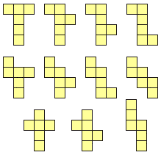

Terminology:

A net is a pattern that you can cut out and fold to make a shape.

- Which of the nets below can be folded into a box without a lid?

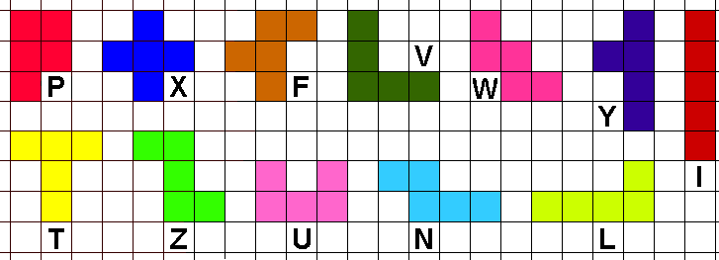

- Check your answer by cutting out some of the shapes below.



